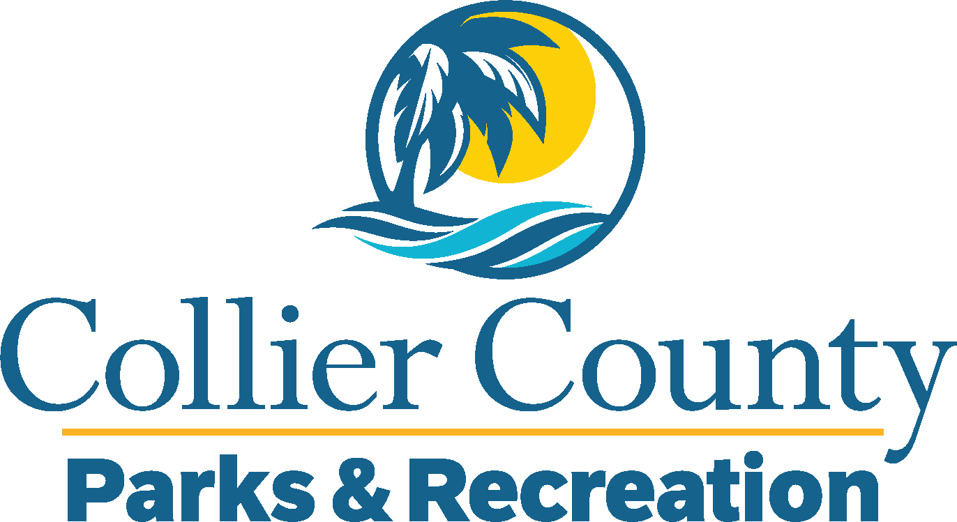
Parks & Recreation Advisory Board

meeting agenda
LOCATION: | NORTH COLLIER REGIONAL PARK
Date: | Wednesday, May 20, 2026
ADDRESS: | 15000 Livingston Road Naples, FL 34109
Time: | 2:00 PM
- Call to order
  - Welcome by the Director
  - Roll Call
  - Verification of Quorum
- Pledge of Allegiance and Invocation
- Approval of the Agenda
- Approval of Previous Meeting Minutes
- New Business
  - Isle of Capri Neighborhood Park Donation– Nicole Esch
  - America 250 Celebration – Marissa Baker
- Additional Materials
  - Golden Gate Community Center Advisory Board Minutes
- Board / Public comments
  - Adopt – A – Park – Advisory Board
- Manager Updates
- Director’s Report
  - Introduction of Assistant Division Director – Sports
  - Immokalee Sports Complex Update
- Adjournment

