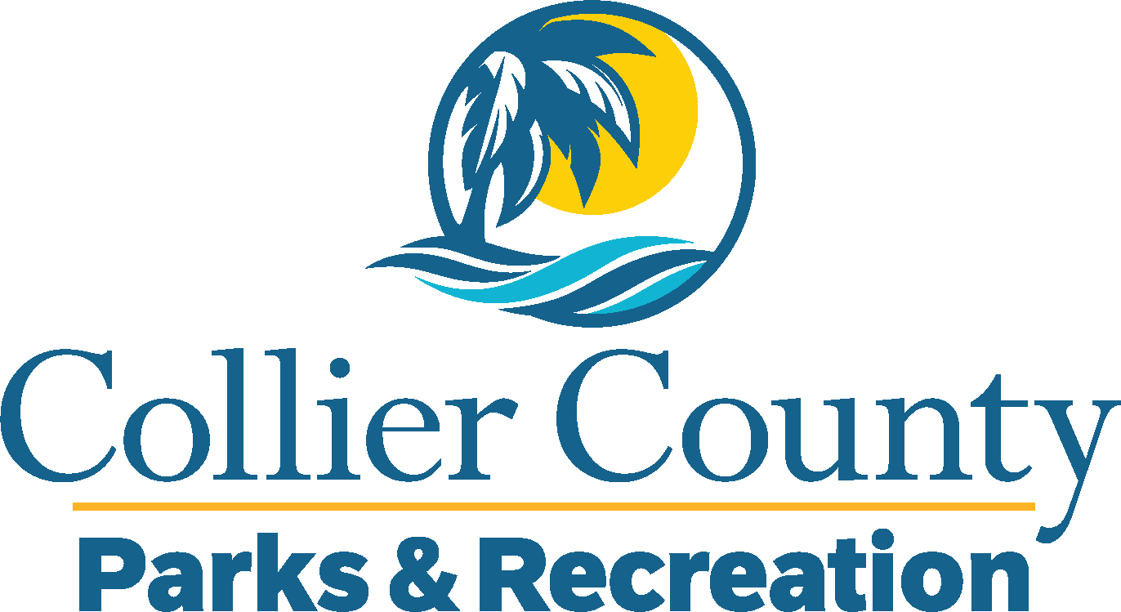
Parks & Recreation Advisory Board

meeting agenda
LOCATION: | NORTH COLLIER REGIONAL PARK
Date: | Wednesday, January 21, 2026
ADDRESS: | 15000 Livingston Road Naples, FL 34109
Time: | 2:00 PM
- Call to order
  - Welcome by the Director
  - Roll Call
  - Verification of Quorum
- Pledge of Allegiance and Invocation
- Approval of the Agenda
- Approval of Previous Meeting Minutes
- New Business
  - Pelican Bay Community Park Update – Randi Swinderman
  - Raquet Ball – Curly Davis
- Old Business
  - Board Vacancies – Miguel Rojas
  - Legends Concert Series – Marissa Baker
  - Golden Gate Community Center Renaming – James Hanrahan
- Additional Materials
  - Golden Gate Community Center Advisory Board Minutes
  - Immokalee Sports Complex – Email Update
- Board / Public comments
- Manager Updates
- Director’s Report
- Adjournment

