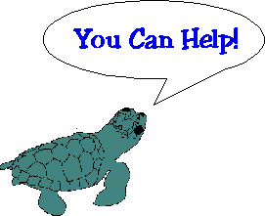You Can Help!

**Please Help Reduce Interference With Sea Turtle Nesting and Hatching Activities.**

* If you find a dead or injured sea turtle, please immediately notify the   
  [Florida Fish and Wildlife Conservation Commission](https://myfwc.com/wildlifehabitats/wildlife/sea-turtle/) at 1- **888-404-3922,**8 a.m. - 8 p.m.; or *FWC or #FWC from a cell phone.
* If you witness a turtle crawling out of the ocean or digging a nest, remain quiet and at a distance. Movements and noises can easily frighten away a female turtle.
* Don't use flashlights on the beach at night. Lights deter turtles attempting to nest.
* If you live near the beach, shield lights that face seaward or turn off unnecessary lighting.
* Never stop a turtle that is returning to the water.
* Please fill in any dug holes for public and environmental safety.
* Do not interfere with hatchlings heading for the water, this can weaken them and increase mortality. **Contact the Florida Fish and Wildlife Conservation Commission (1-888-404-3922) if you witness any situation that may *interfere with sea turtle activities***

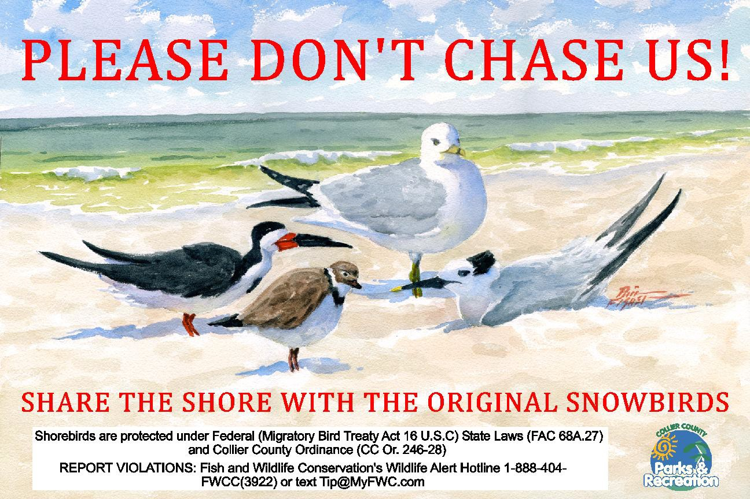

***Local artist Phil Fisher donated the original artwork for this sign.***