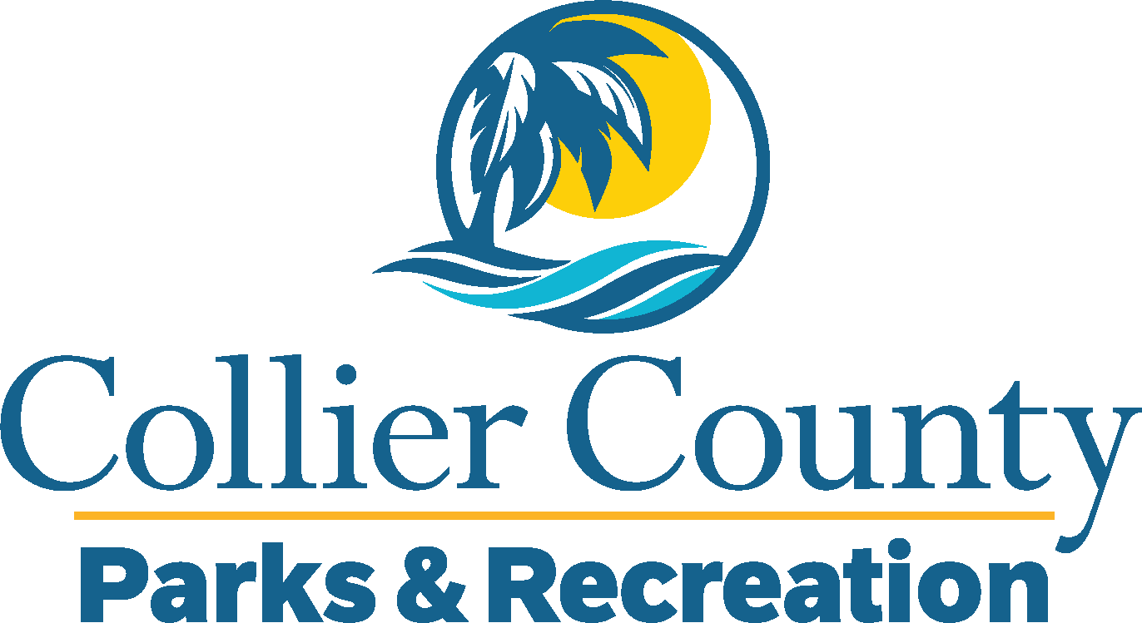
Parks & Recreation Advisory Board

meeting agenda
LOCATION: | North Collier Regional Park -Administration
Date: | Wednesday, September 17, 2025
ADDRESS: | 15000 Livingston Road Naples, Fl
Time: | 2:00 PM
- Call to order
  - Welcome by the Director
  - Roll Call
  - Verification of Quorum
- Pledge of Allegiance and Invocation
- Approval of the Agenda
- Approval of Previous Meeting Minutes
- New Business
  - Naples Boat Show – Tiffany Sawyer
- Old Business
  - Legends Concert Series – Marissa Baker
  - Vacancy Applicants – James Hanrahan
- Board / Public comments
- Manager Updates
- Director’s Report
- Adjournment

