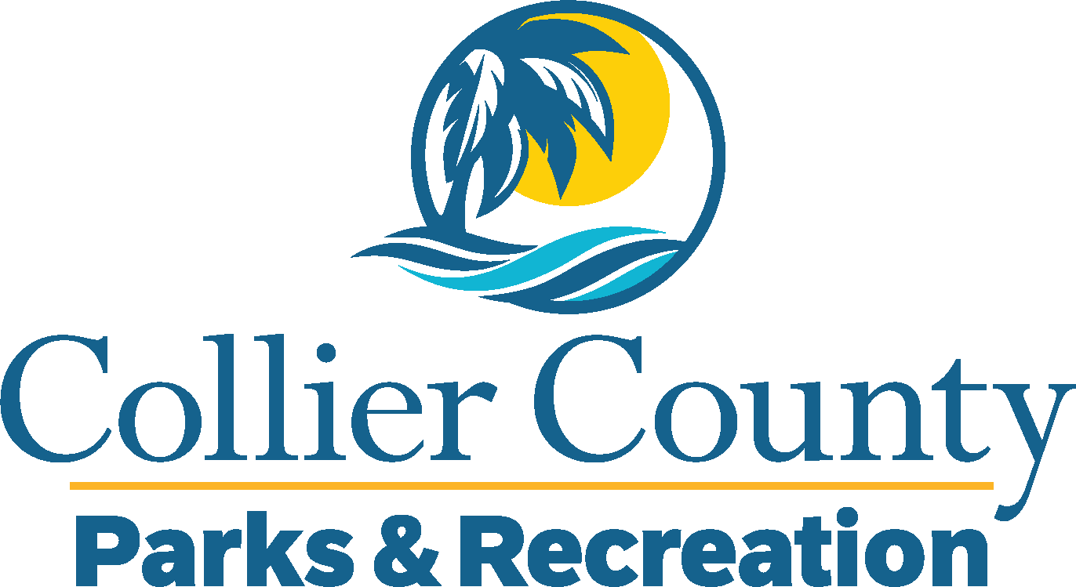
Parks & Recreation Advisory Board

meeting agenda
LOCATION: | North Collier Regional Park -Administration
Date: | Wednesday, March 19, 2025
ADDRESS: | 15000 Livingston Road Naples, Fl
Time: | 2:00 PM
- Call to order
  - Welcome by the Director
  - Roll Call
  - Verification of Quorum
- Pledge of Allegiance and Invocation
- Approval of the Agenda
- Approval of Previous Meeting Minutes
- New Business
  - Purrs & Paddles Pickleball Tournament Alcohol Sale and Consumption – Jim RIch
  - Collier 311 Presentation – Rafaela Zapata
  - Wikiloc Outdoor Navigation GPS – Duke Vasey
  - Bayview Agreement – James Hanrahan
  - Naples Roller Hockey - Justin Lund
- Board / Public comments
- Manager Updates
- Director’s Report
- Adjournment

