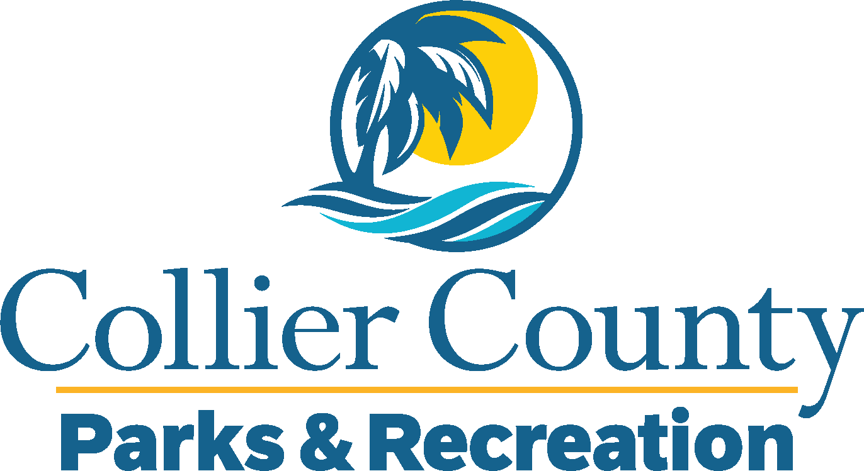
Parks & Recreation Advisory Board

meeting agenda
LOCATION: | Max Hasse Community Park
Date: | Wednesday, June 18, 2025
ADDRESS: | 3390 Golden Gate Blvd W, Naples, FL 34117
Time: | 2:00 PM
- Call to order
  - Welcome by the Director
  - Roll Call
  - Verification of Quorum
- Pledge of Allegiance and Invocation
- Approval of the Agenda
- Approval of Previous Meeting Minutes
- New Business
  - Welcome to Max Hasse – Kyle Bregenzer
  - Summer Camp – Randi Swinderman
  - U.S. Open Pickleball – Bob Bowman
- Old Business
  - Attendance Update – James Handrahan
  - Letter of Support – James Hanrahan
- Board / Public comments
- Manager Updates
- Director’s Report
- Adjournment

