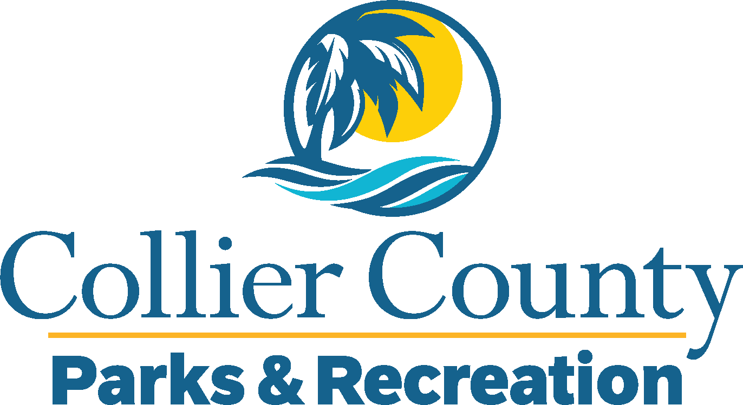
Parks & Recreation Advisory Board

meeting agenda
LOCATION: | North Collier regional park
Date: | Wednesday, August 13, 2025
ADDRESS: | 15000 Livingston Road Naples, FL 34109
Time: | 2:00 PM
- Call to order
  - Welcome by the Director
  - Roll Call
  - Verification of Quorum
- Pledge of Allegiance and Invocation
- Approval of the Agenda
- Approval of Previous Meeting Minutes
- New Business
  - Legends Concert Series – Mike Randall
  - Fee Policy Study – James Hanrahan
  - Collier County Field Inventory – Said Gomez
  - Hunden Studies – Marissa Baker
      - Paradise Coast Sports Complex
      - Sun-N- Fun Lagoon
- Board / Public comments
- Manager Updates
- Director’s Report
- Adjournment

