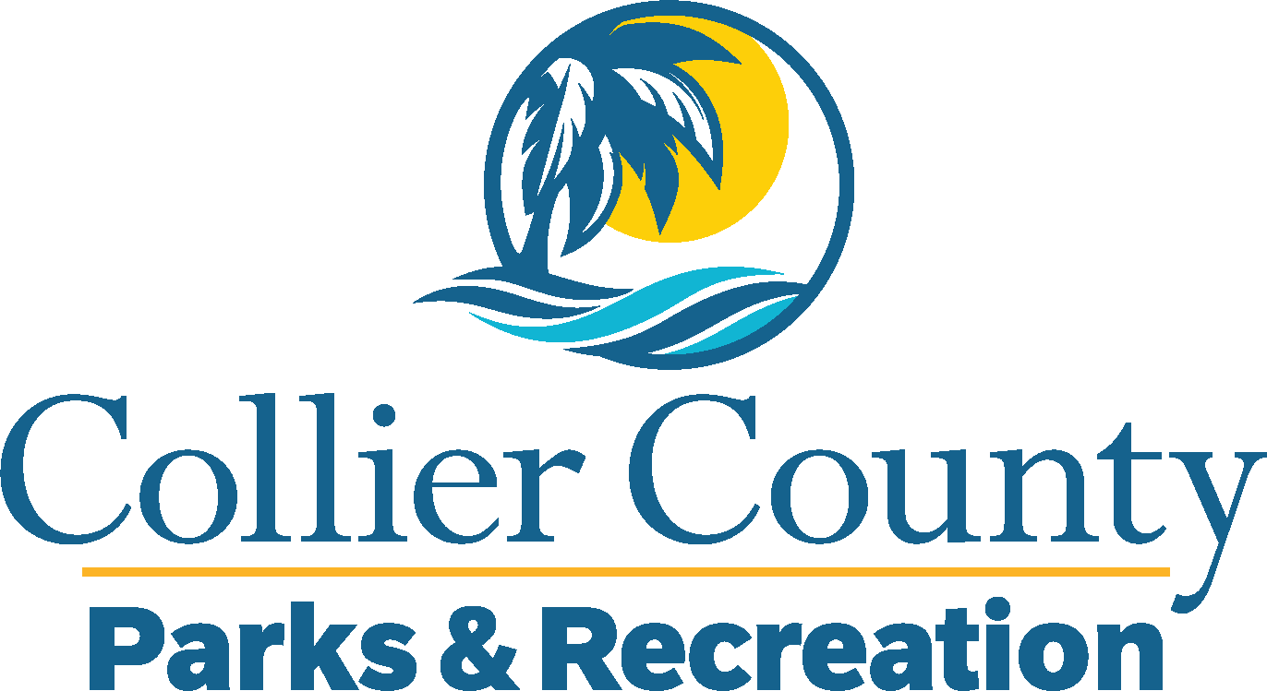
Parks & Recreation Advisory Board

meeting agenda
LOCATION: | Golden Gate community center
Date: | Wednesday, April 16, 2025
ADDRESS: | 4701 Golden Gate Parkway, Naples, FL 34116
Time: | 2:00 PM
- Call to order
  - Welcome by the Director
  - Roll Call
  - Verification of Quorum
- Pledge of Allegiance and Invocation
- Approval of the Agenda
- Approval of Previous Meeting Minutes
- New Business
  - Introduction to Golden Gate Community Center
  - Purrs and Paddles Pickleball Event
- Board / Public comments
- Manager Updates
- Director’s Report
- Adjournment

