Parks & Recreation Advisory Board

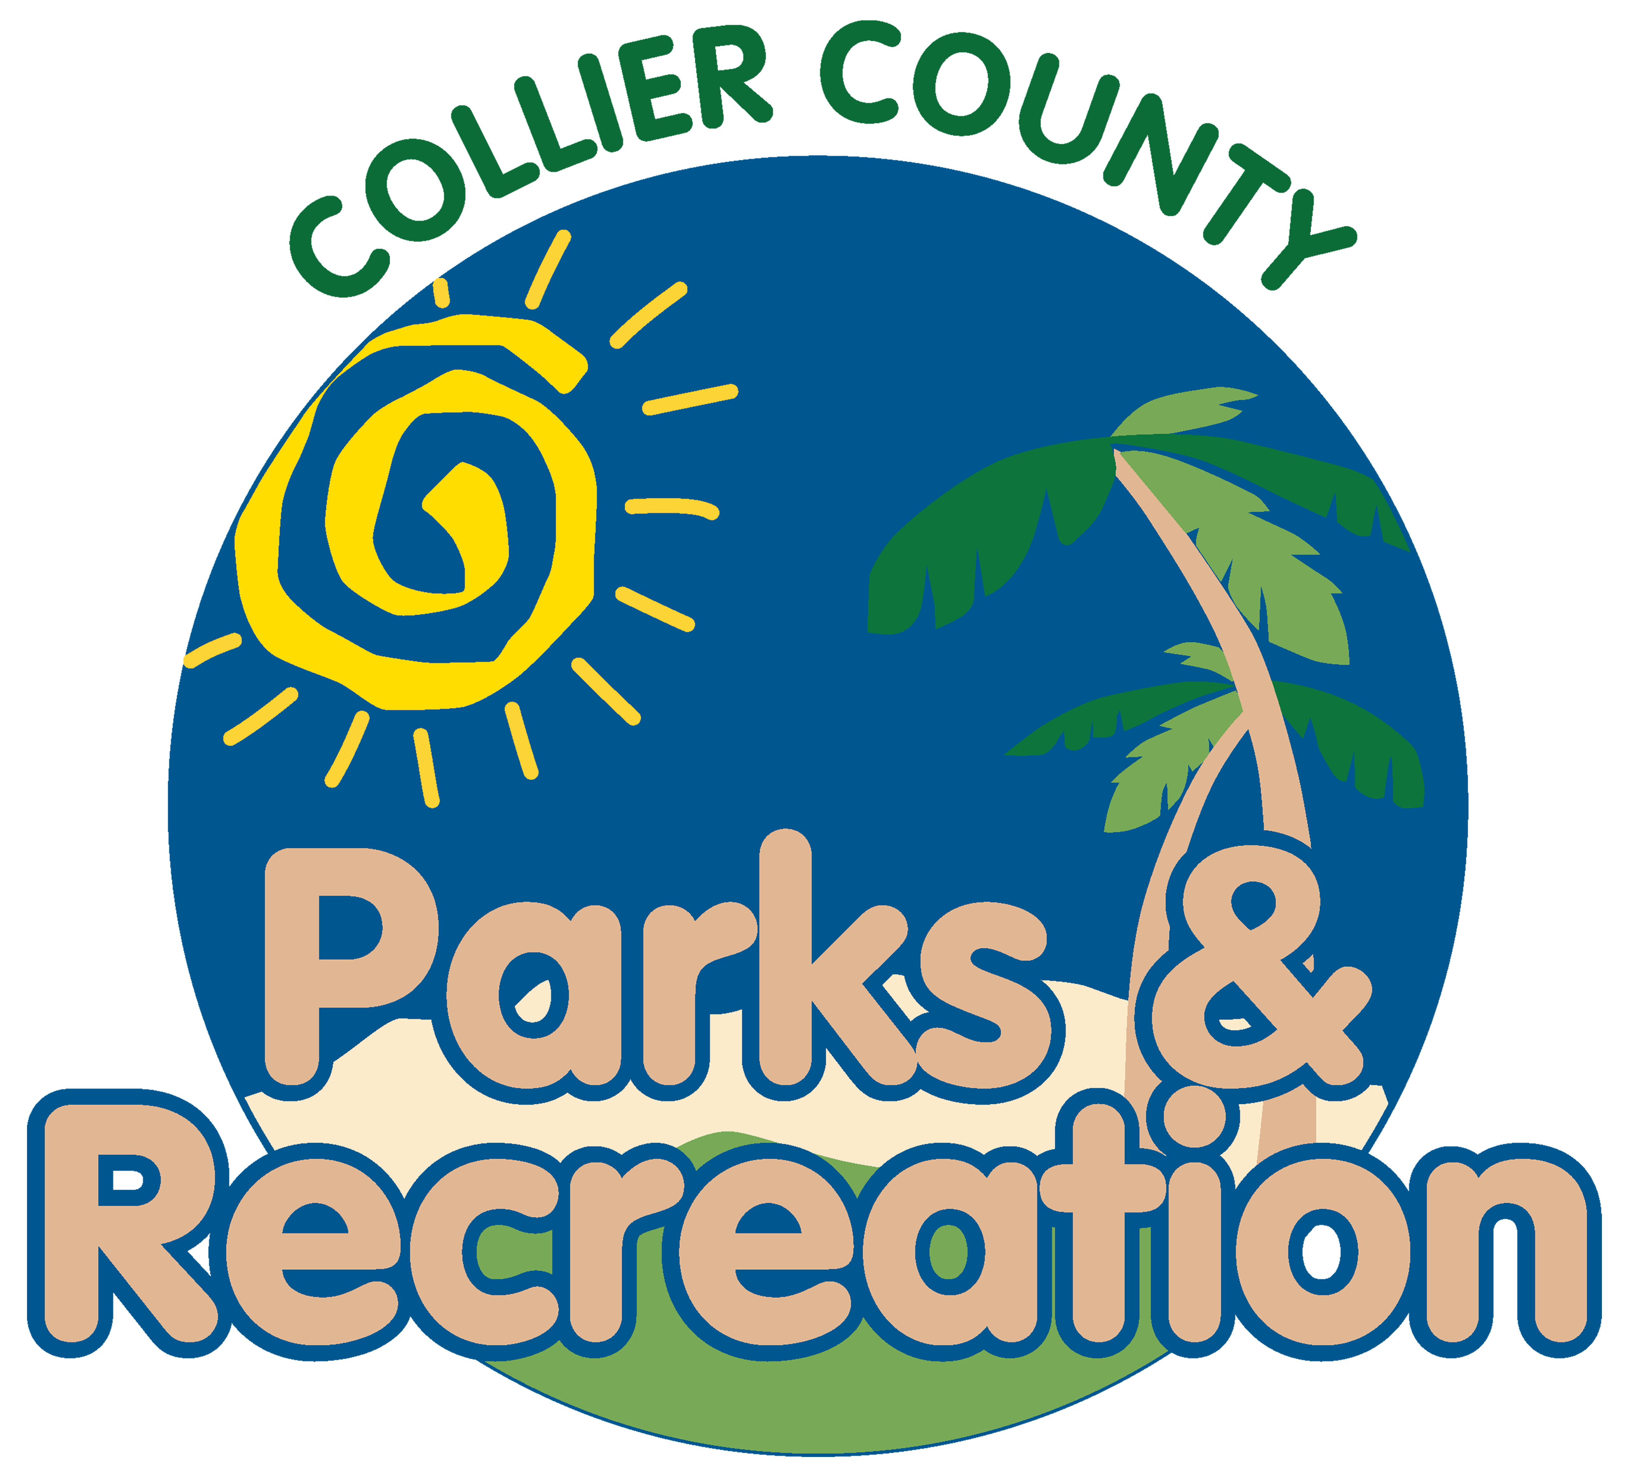
meeting agenda
LOCATION: | Immokalee South Park
Date: | Wednesday, June 19, 2024
ADDRESS: | 418 School Dr, Immokalee, FL 34142
Time: | 6:00 PM
- Call to order
  - Welcome by Director
  - Roll Call
  - Verification of Quorum
- Pledge of Allegiance and Invocation
- Approval of the Agenda
- Approval of Previous Meeting Minutes
- new business
  - Immokalee Parks
- Old Business
  - Immokalee Sports Complex Update
  - Pickleball Contract Update
  - Aquatic Facilities Update
- Public comments
- staff Reports
- Director’s Report
- Adjournment

