Parks & Recreation Advisory Board

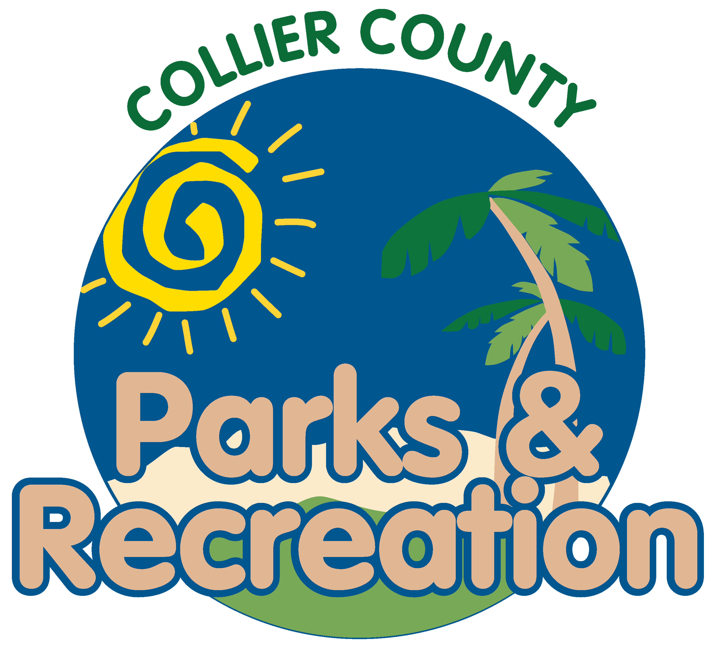
meeting agenda
LOCATION: | North Collier Regional Park
Date: | Wednesday, August 21, 2024
ADDRESS: | 15000 Livingston Road Naples, FL 34109
Time: | 2:00 PM
- Call to order
  - Welcome by the Director
  - Roll Call
  - Verification of Quorum
- Pledge of Allegiance and Invocation
- Approval of the Agenda
- Approval of Previous Meeting Minutes
- introduction to Golden Gate Community Park
- New Business
  - Summer Camp Re-Cap
- OLD BUSINESS
  - U.S. Open Pickleball
  - Non-Motorized use on Lake Avalon
- Public comments
- Director’s Report
- Adjournment

