Parks & Recreation Advisory Board

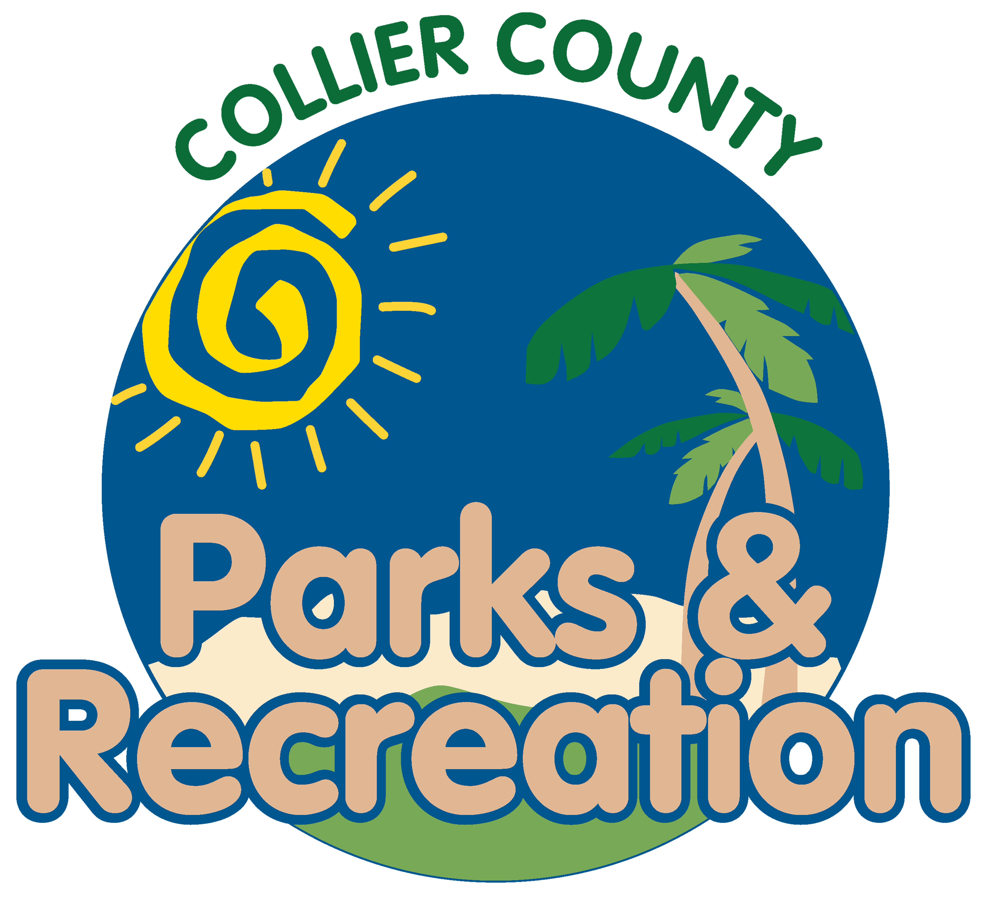
meeting agenda
LOCATION: | Vineyards community Park–community center
Date: | Wednesday, April 17, 2024
ADDRESS: | 6231 Arbor Blvd W, Naples, FL 34119
Time: | 2:00 PM
- Call to order
  - Welcome by Director
  - Roll Call
  - Verification of Quorum
- Pledge of Allegiance and Invocation
- Approval of the Agenda
- Approval of Previous Meeting Minutes
- new business
  - Welcome to Vineyards
  - Pelican Bay Community Park Update
  - Superintendent and Director Update
  - Parks Short-Term Goals
- Public comments
- staff Reports
- Director’s Report
- Adjournment

