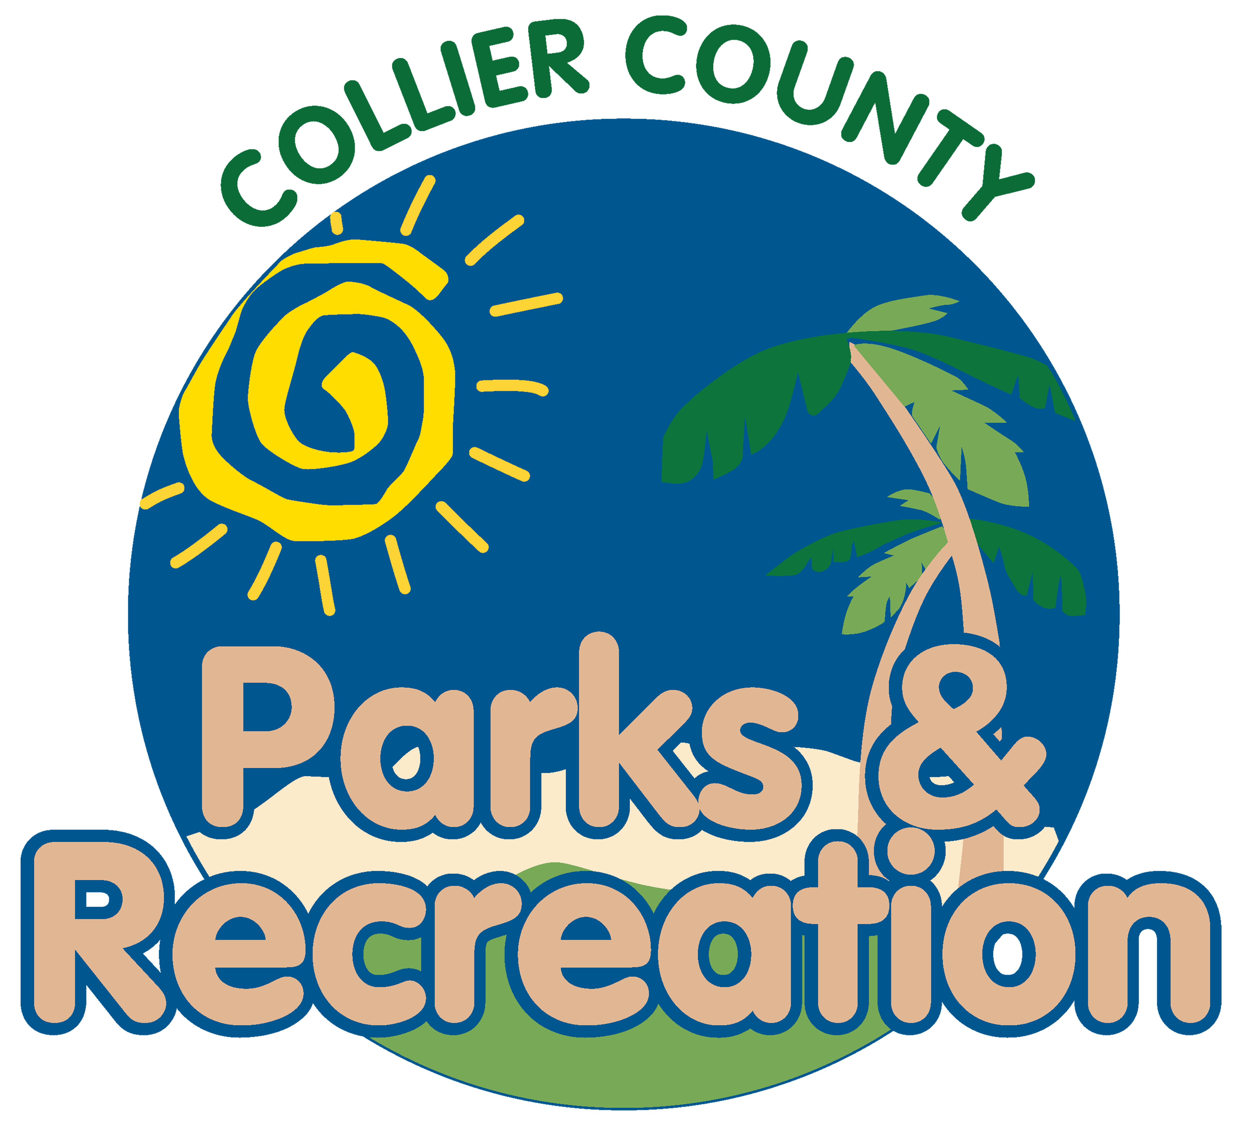

Parks & Recreation Advisory Board

meeting agenda
LOCATION: | Immokalee Sports Complex
Date: | Wednesday, September 20, 2023
ADDRESS: | 505 Escambia St, Immokalee, FL 34142
Time: | 2:00 PM

- Call to order
- Pledge of Allegiance and Invocation
- Approval of the Agenda
- Approval of minutes from last meeting
- Manager Updates
- new business
  - Christmas Around the World
  - Parks Maintenance Accomplishments Immokalee Update
  - Immokalee Sports Complex Update
- director highlights
- Adjournment

