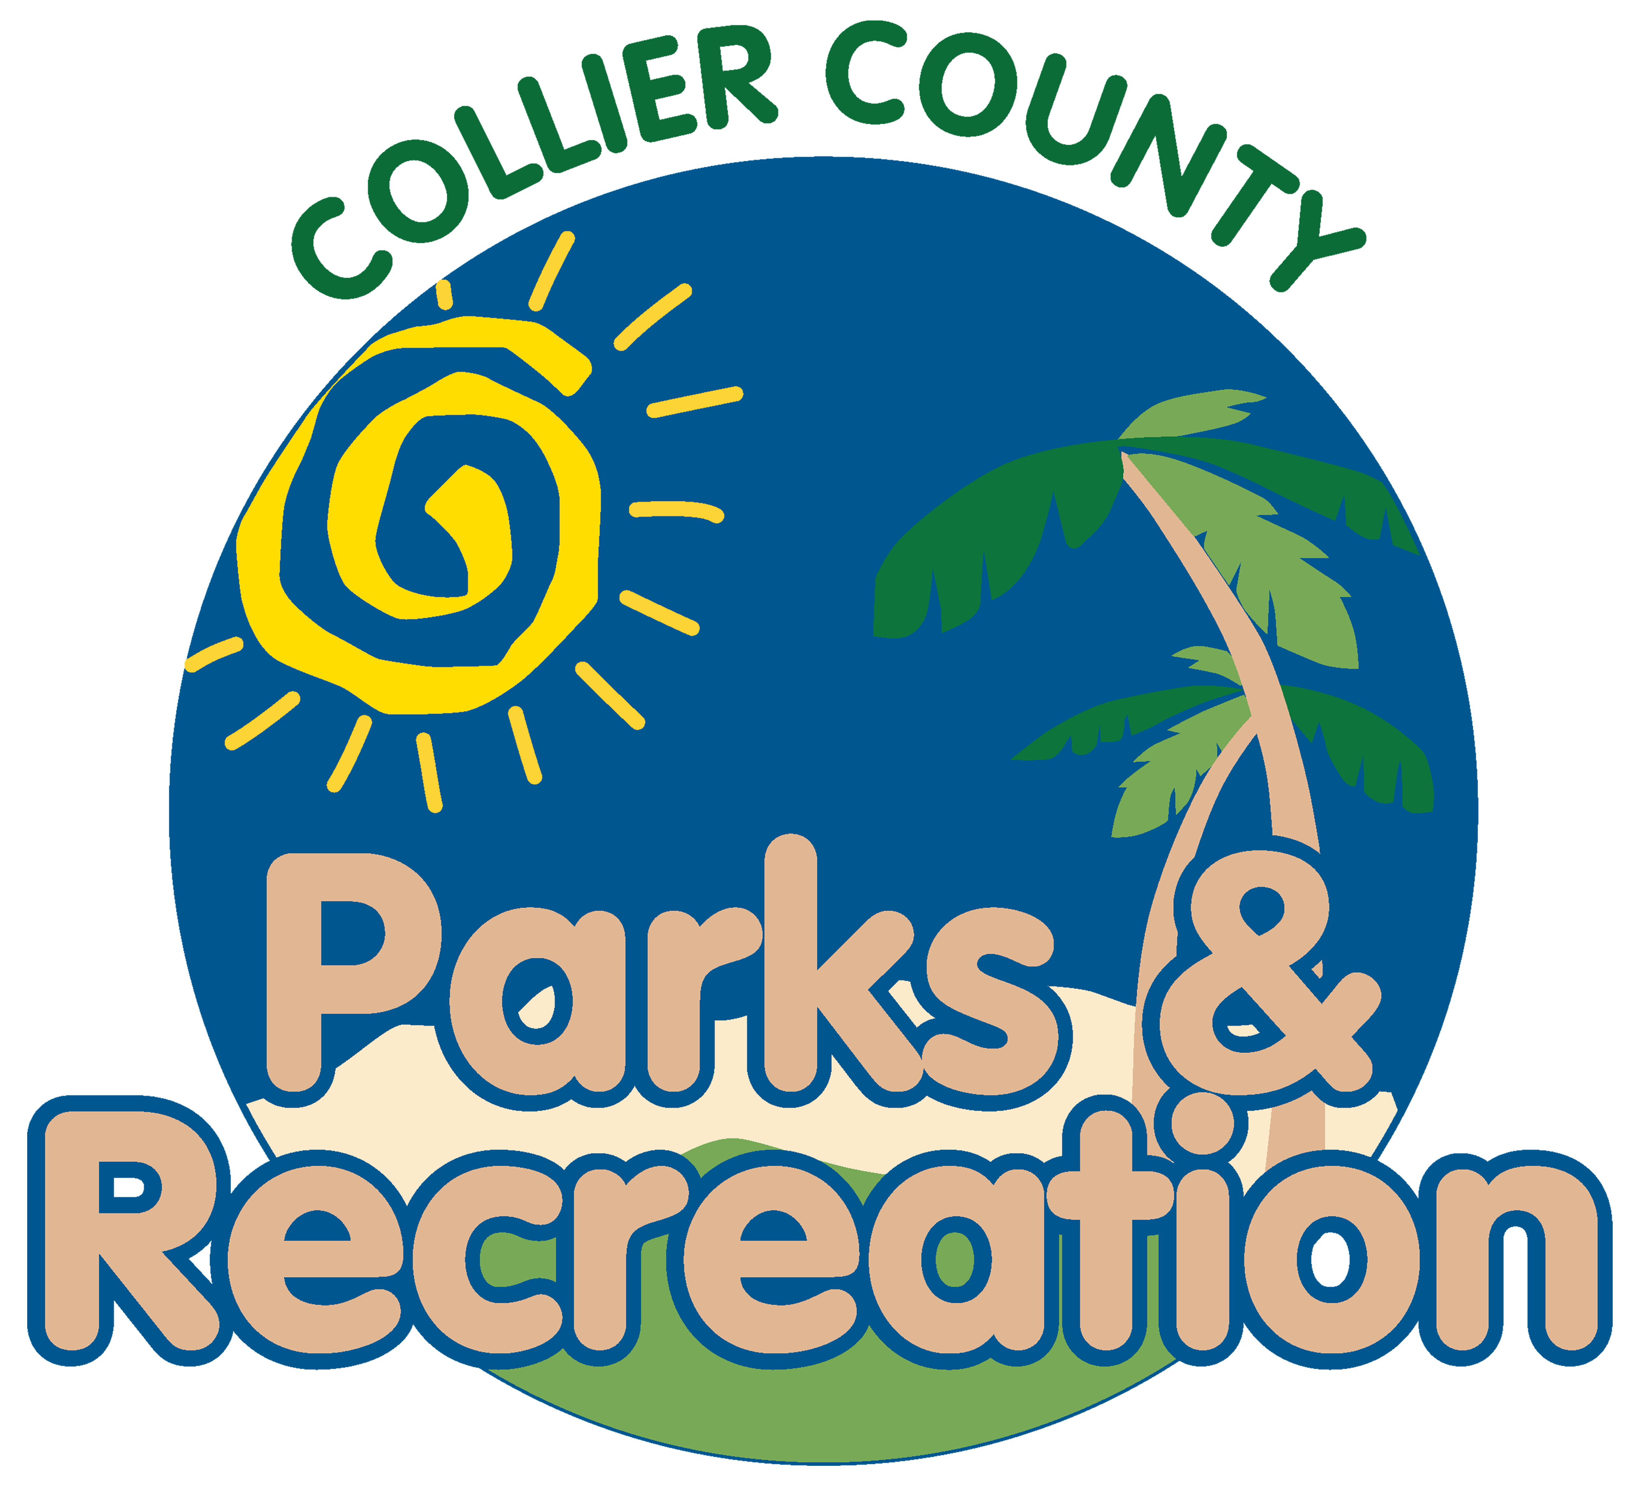

Parks & Recreation Advisory Board

meeting agenda
LOCATION: | North Collier Regional Park - Administration
Date: | Wednesday, November 15, 2023
ADDRESS: | 15000 Livingston Road Naples, Florida 34109
Time: | 2:00 PM

- Call to order
- Pledge of Allegiance and Invocation
- Approval of the Agenda
- Approval of minutes from last meeting
- new business
  - Advisory Board Vacancies
  - Capital Projects Update
  - Naples Grande Second Amendment Draft
- Manager Updates
- director highlights
- Adjournment

