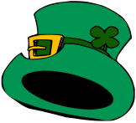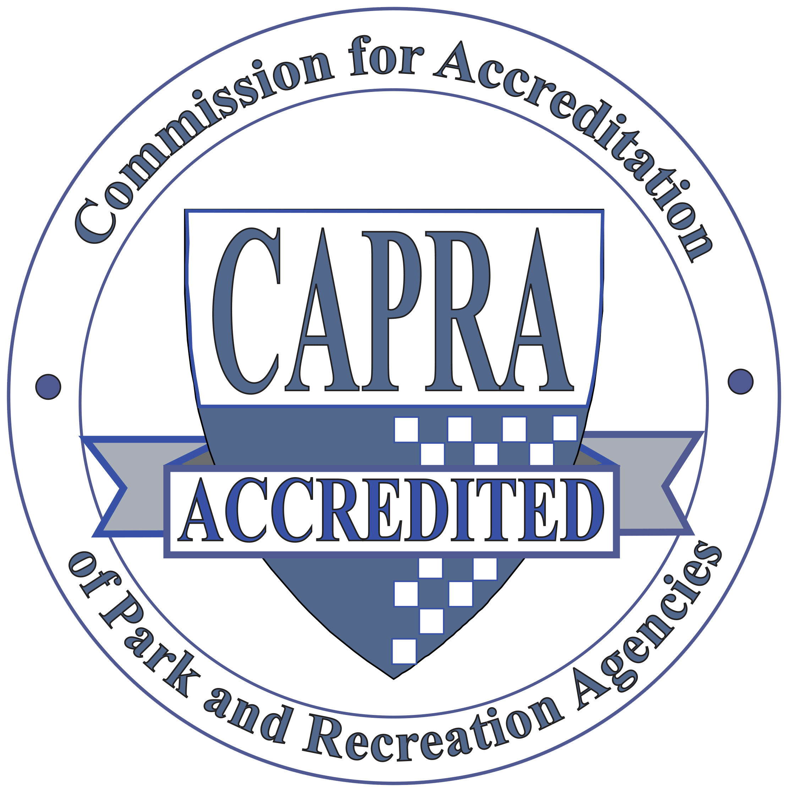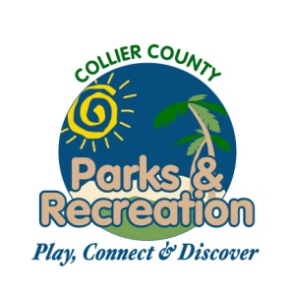

1. **Call to Order**
2. **Pledge of Allegiance and Invocation**
3. **Approval of Agenda**
4. **Approval of February 17, 2016 Minutes**
5. **Staff Highlights**
   1. **Report on Pinterest**
6. **Old Business**
   1. **Field Utilization Recommendations**
7. **New Business**
   1. **Alcohol Permission –ENCP**
   2. **Cocohatchee River Park Improvements/Conceptual Plan**
8. **Adopt a Park reports**
9. **Director Highlights—Barry Williams**
10. **Informational Items**
11. **Public Comments/Board Comments**
12. **Adjournment**

**Parks and Recreation**

**Advisory Board Meeting**

**March 16, 2016 2:00PM**

**North Collier Regional Park**