

**Parks and Recreation**

**Advisory Board Meeting**

**January 20, 2016 2:00PM**

**North Collier Regional Park**

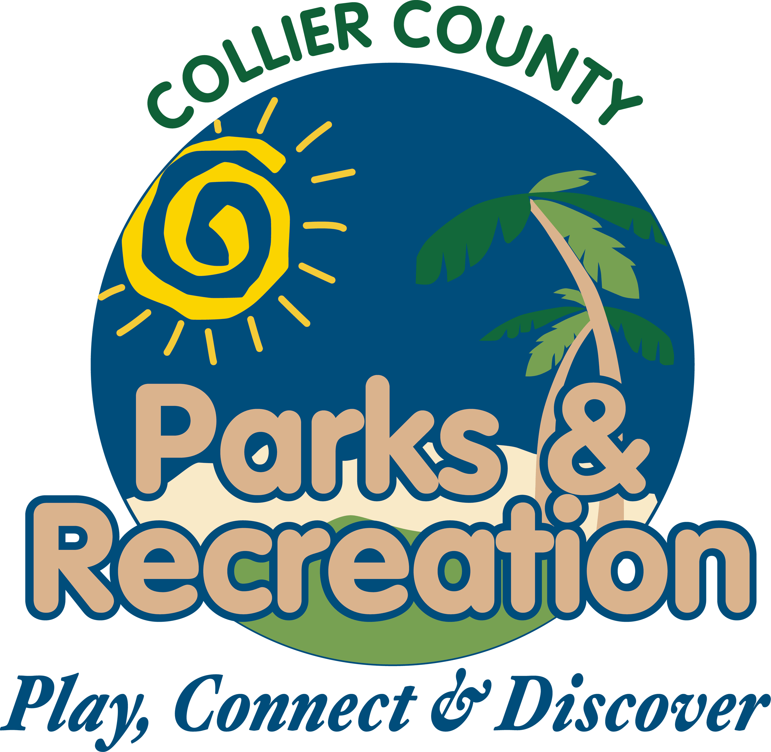

1. **Call to Order**
2. **Pledge of Allegiance and Invocation**
3. **Approval of Agenda**
4. **Approval of December 21, 2015 Minutes**
5. **Staff Highlights**
   1. **Active Net and Online Registration**
6. **New Business**
7. **Selection of officers for 2016**
8. **AUIR**
9. **Review field utilization data**
10. **Naming of the GGCP dog park**
11. **Old Business**
12. **Out of cycle TDC Grant for additional maintenance staff at beach parks**
13. **Adopt a Park reports**
14. **Director Highlights—Barry Williams**
15. **Informational Items**
16. **Public Comments/Board Comments**
17. **Adjournment**