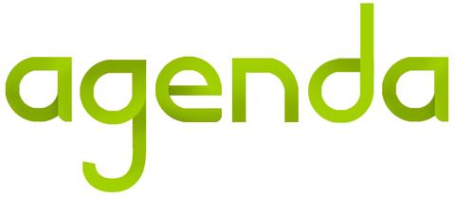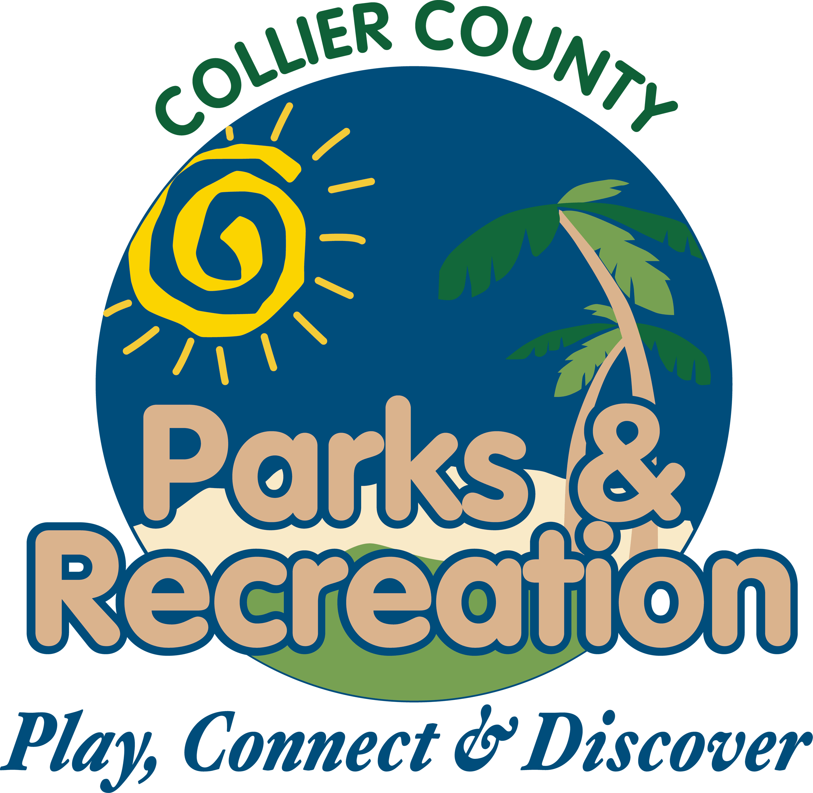

1. **Call to Order**
2. **Pledge of Allegiance and Invocation**
3. **Approval of Agenda**
4. **Approval of January 20,2016 Minutes**
5. **Staff Highlights**
   1. **Parks After the Storm (Jan. 16) – Rick Garby**
   2. **Caxambas Conversion –**

**Amanda Townsend**

1. **New Business**
2. **Alcohol Permission –**

**Harvest Festival**

1. **Parks Capital Project**

**Plan**

1. **Adopt a Park reports**
2. **Director Highlights—**

**Barry Williams**

1. **Informational Items**
2. **Public Comments/Board Comments**
3. **Adjournment**

**Parks and Recreation**

**Advisory Board Meeting**

**February 17, 2016 2:00PM**

**Immokalee Community Park**