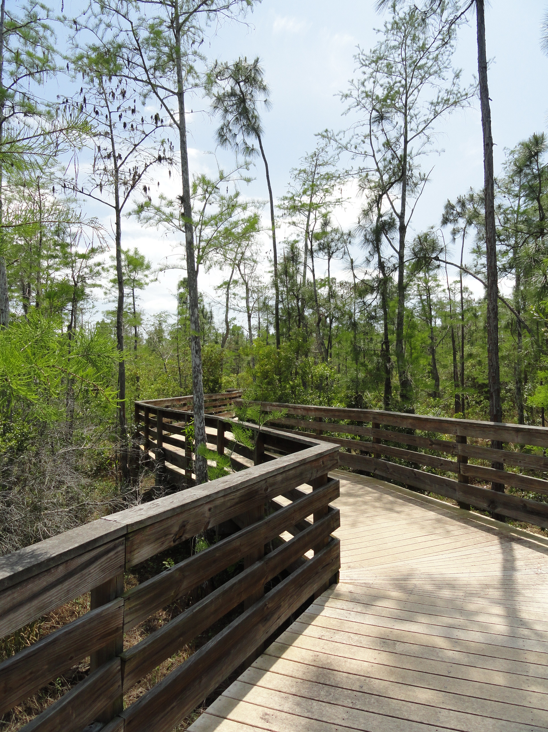
Parks and Recreation Advisory Board Meeting
April 15, 2015 2:00 P.M.
North Collier Regional Park
- Call to Order
- Pledge of Allegiance and Invocation
- Approval of Agenda
- Approval of February 2015 Minutes
- Staff Highlights
- Capital Project Review—Facilities Management
- New Business
- Employee of the Month
- Five year Capital Plan 2015-2020\
- Clam Pass Concession Re-decking
- Old Business
- Dog Park Update
- Clam Pass southern update
- Adopt a Park reports
- Director Highlights—Barry Williams
- Informational Items
- Public Comments/Board Comments
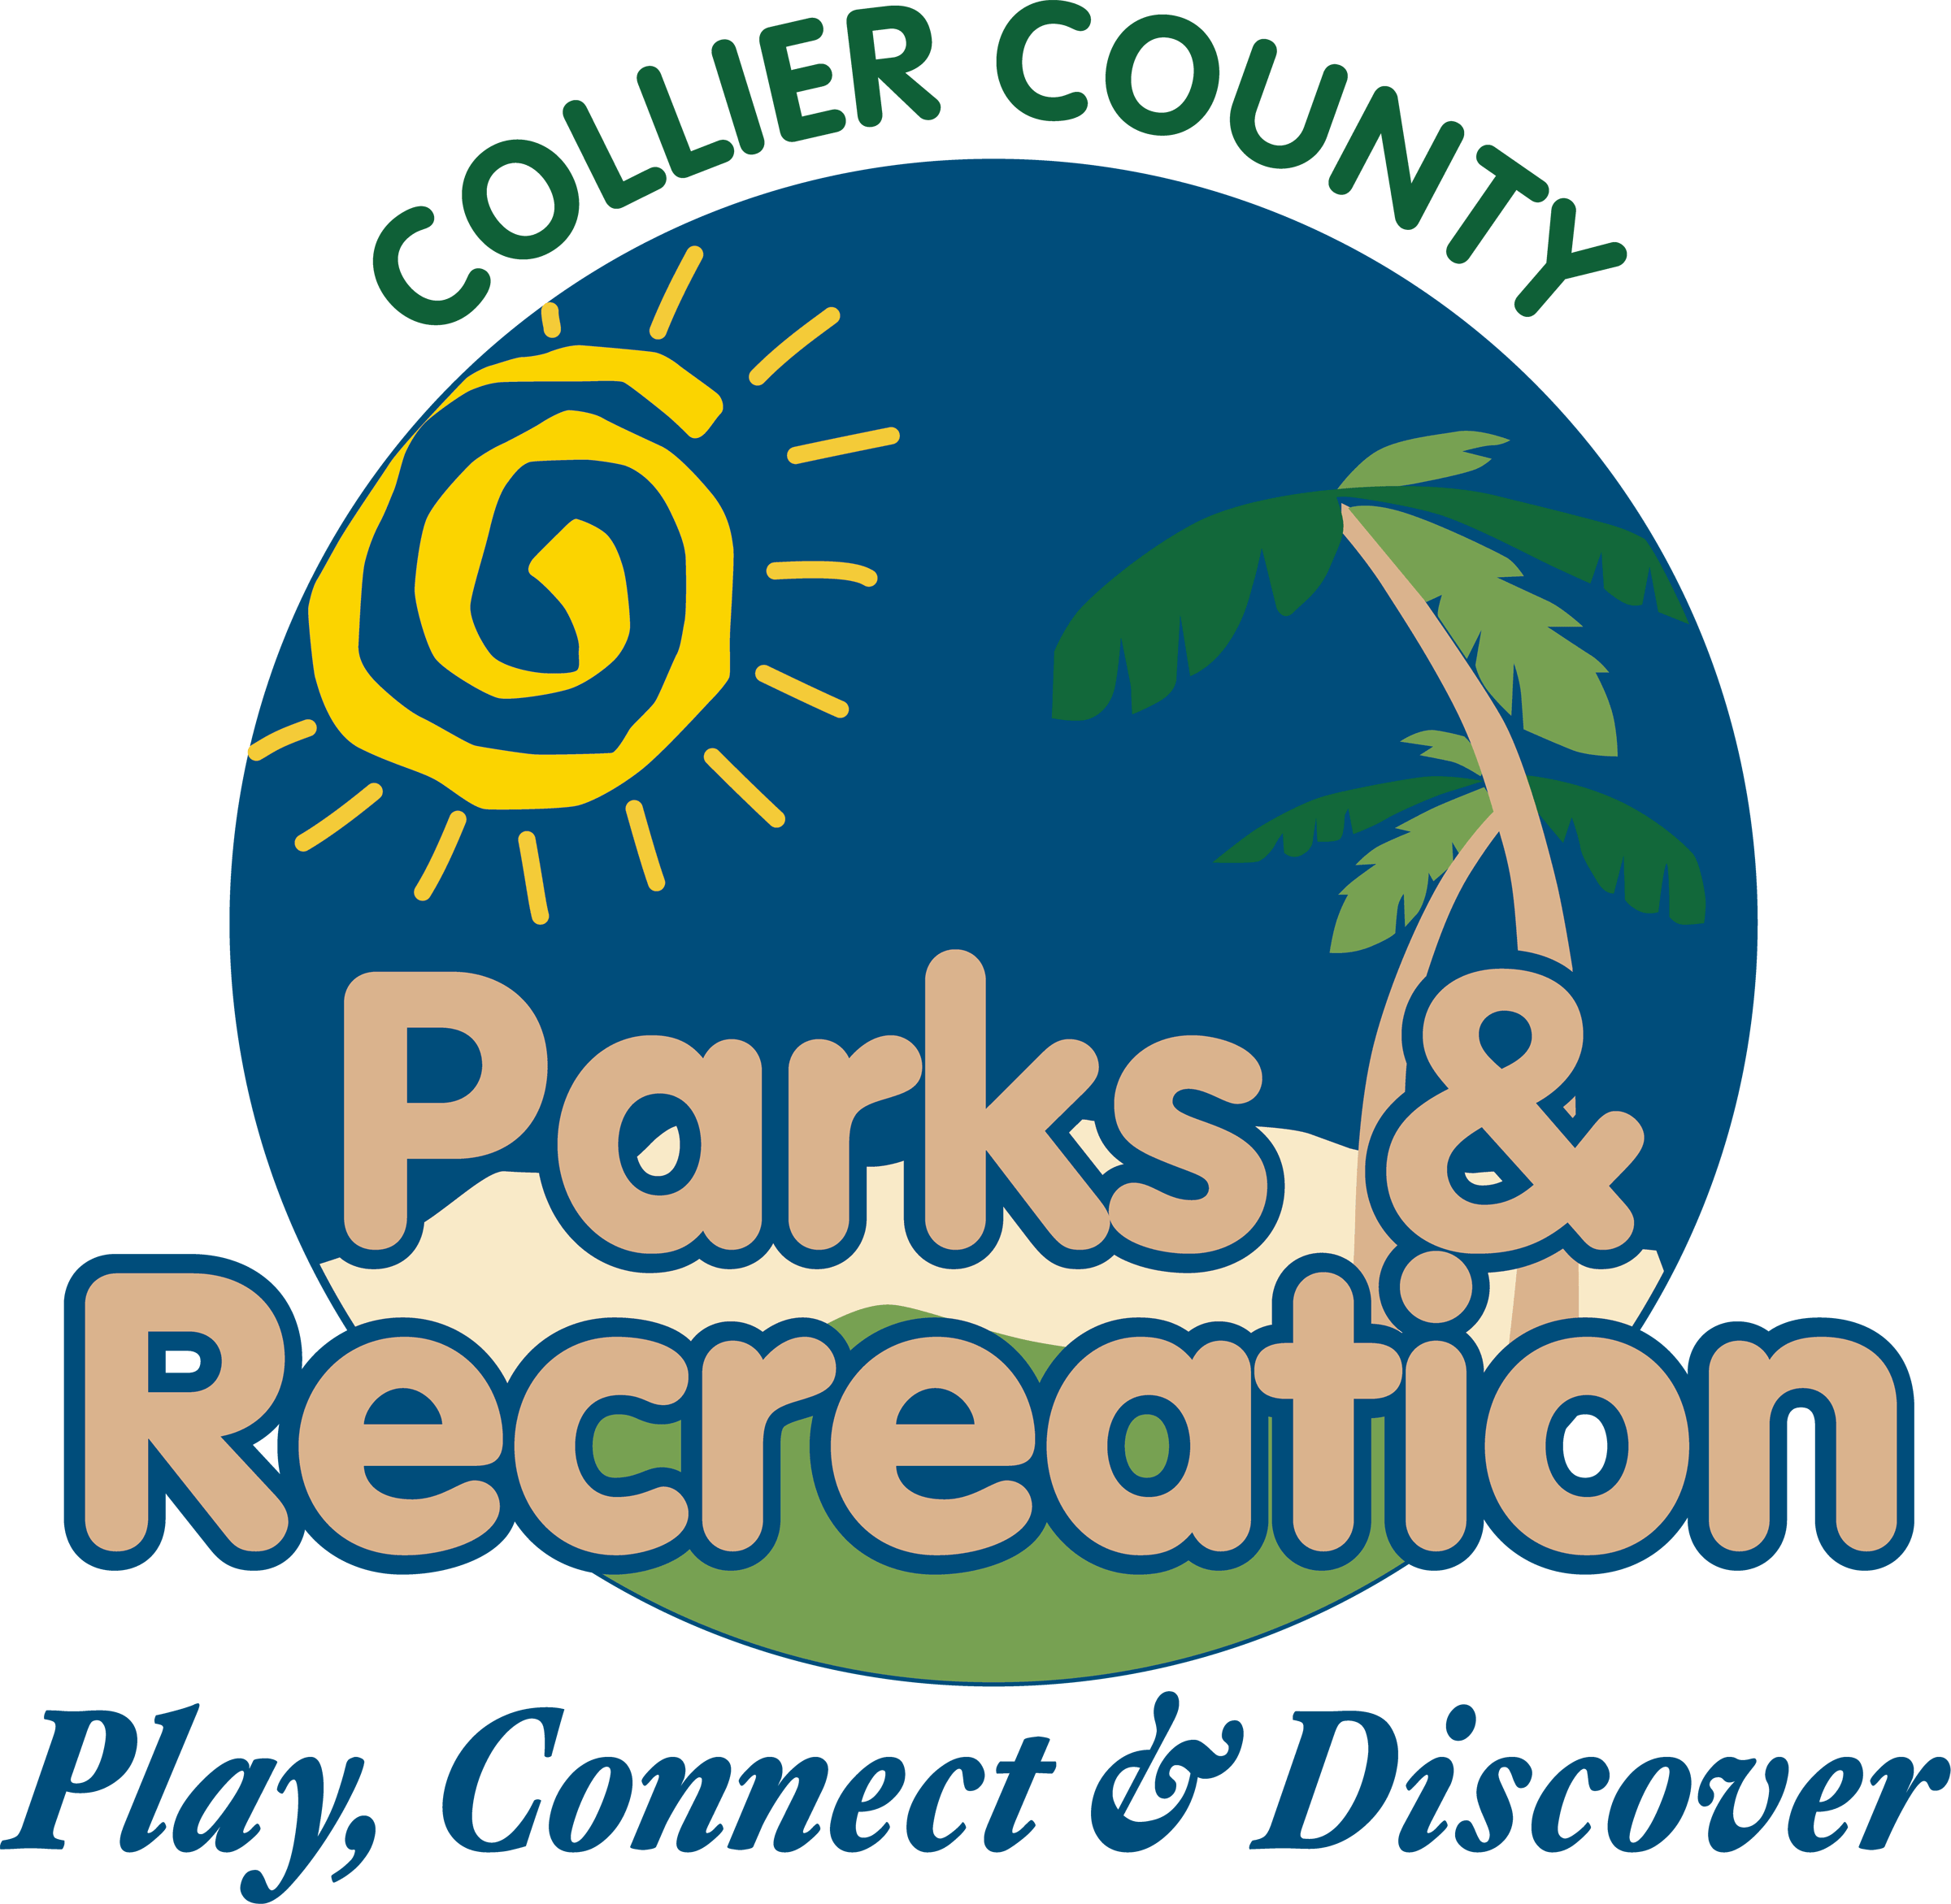
- Adjournment

