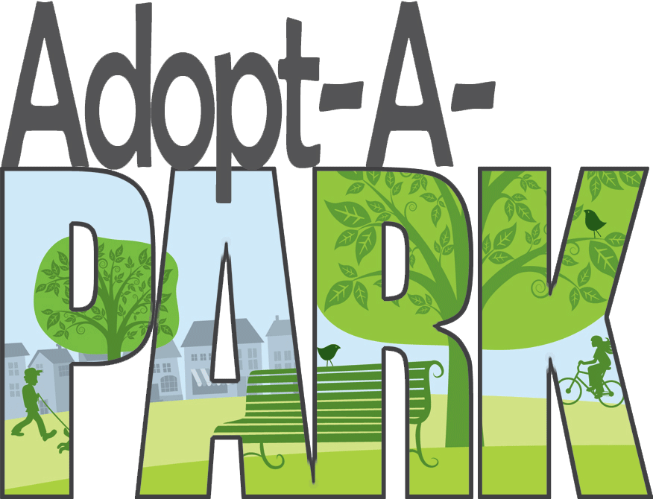

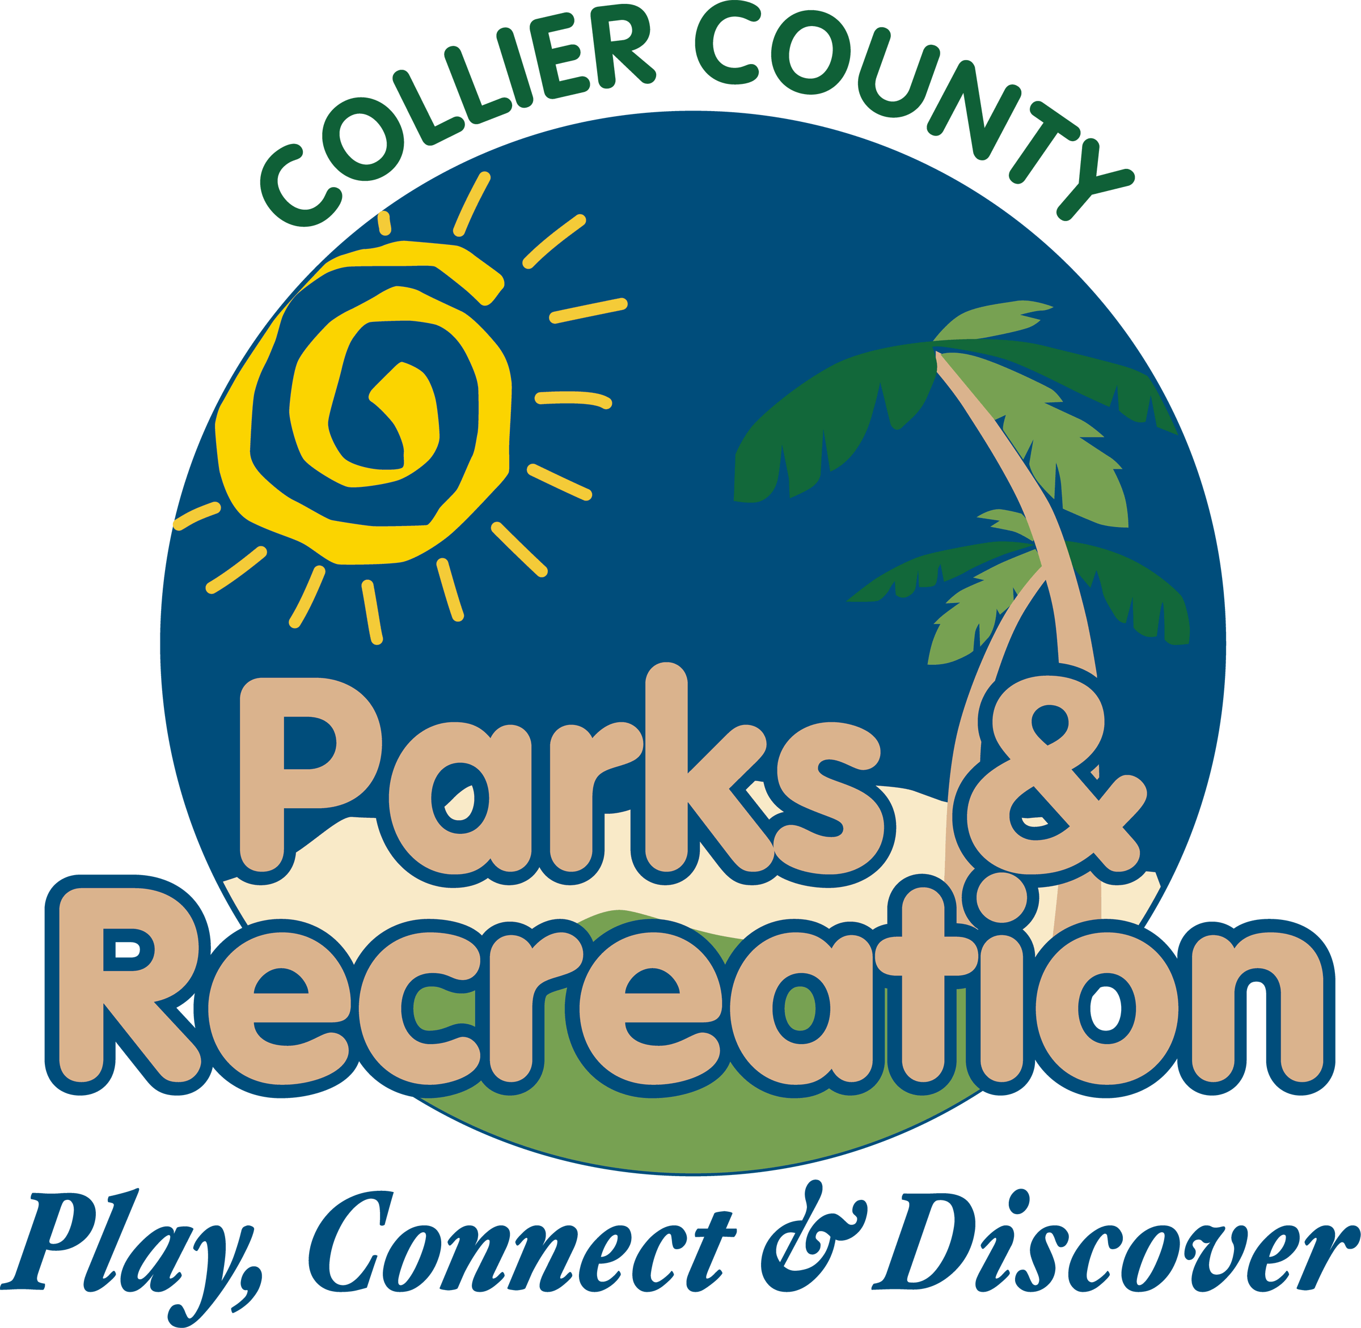

ADVISORY BOARD MEMBER: Choose an item.
DATE OF VISIT: Click here to enter a date.

TIME OF VISIT: Choose an item.

Evaluate the Park!

ATTRACTIVE Yes CLEAN/ WELL MAINTAINED Choose an item.
COMFORTABLE PLACES TO SIT No FEELS SAFE Choose an item.
AREA IS BUSY No PEOPLE IN GROUPS Choose an item.
EVIDENCE OF VOLUNTERRISM No AREA IS VITAL ECONOMICALLY Choose an item.
DOES THE LOCATION HAVE FIELDS No CONDITION OF THE FIELDS Choose an item.

HOW MANY PEOPLE WERE IN THE FACILITY AT THE TIME OF YOUR VISIT? Click here to enter text.
WERE CHILDREN AND SENIORS PRESENT Yes
WOULD YOU RECOMMEND THIS FACILITY Choose an item.
WHAT DO YOU LIKE BEST ABOUT THIS PLACE? Click here to enter text.

LIST THREE THINGS THAT YOU WOULD DO TO IMPROVE THIS PLACE THAT COULD BE DONE RIGHT AWAY AND THAT WOULDN'T COST A LOT:

- Click here to enter text.
- Click here to enter text.
- Click here to enter text.

WHAT 3 CHANGES WOULD YOU MAKE IN THE LONG TERM THAT WOULD HAVE THE BIGGEST IMPACT?

- Click here to enter text.
- Click here to enter text.
- Click here to enter text.

ASK SOMEONE WHO IS IN THE "PLACE: WHAT THEY LIKE ABOUT IT AND WHAT THEY WOULD TO DO IMPROVE IT: Click here to enter text.

WHAT LOCAL PARTNERSHIPS OR LOCAL TALENT CAN YOU IDENTIFY THAT COULD HELP IMPLEMENT SOME OF YOUR PROPOSED IMPROVEMENTS? PLEASE BE AS SPECIFIC AS POSSIBLE: Click here to enter text.

COMMENTS & SUGGESTIONS:
Click here to enter text.

