ATV meeting
May 7, 2015
North Collier Regional Park
- Introduction

- Approve Agenda

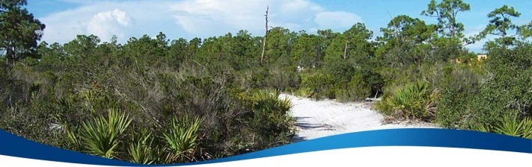
- Approve Previous Meeting Minutes

- Update regarding Florida Tracks and Trails proposal and site

- Possible alternatives within Collier County

- Possible alternatives outside of Collier County

- Future status of the Ad Hoc Committee (sunset date 6-12-15)

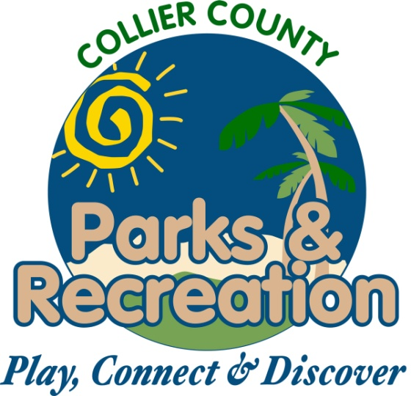
- Moving forward

