
You Can Help!
Please Help Reduce Interference With Sea Turtle Nesting and Hatching Activities.

- If you find a dead or injured sea turtle, please immediately notify the
Florida Fish and Wildlife Conservation Commission at 1- 888-404-3922,
8 a.m. - 8 p.m.; or *FWC or #FWC from a cell phone.
- If you witness a turtle crawling out of the ocean or digging a nest, remain quiet and at a distance. Movements and noises can easily frighten away a female turtle.
- Don't use flashlights on the beach at night. Lights deter turtles attempting to nest.
- If you live near the beach, shield lights that face seaward or turn off unnecessary lighting.
- Never stop a turtle that is returning to the water.
- Please fill in any dug holes for public and environmental safety.
- Do not interfere with hatchlings heading for the water, this can weaken them and increase mortality. Contact the Florida Fish and Wildlife Conservation Commission (1-888-404-3922) if you witness any situation that may interfere with sea turtle activities
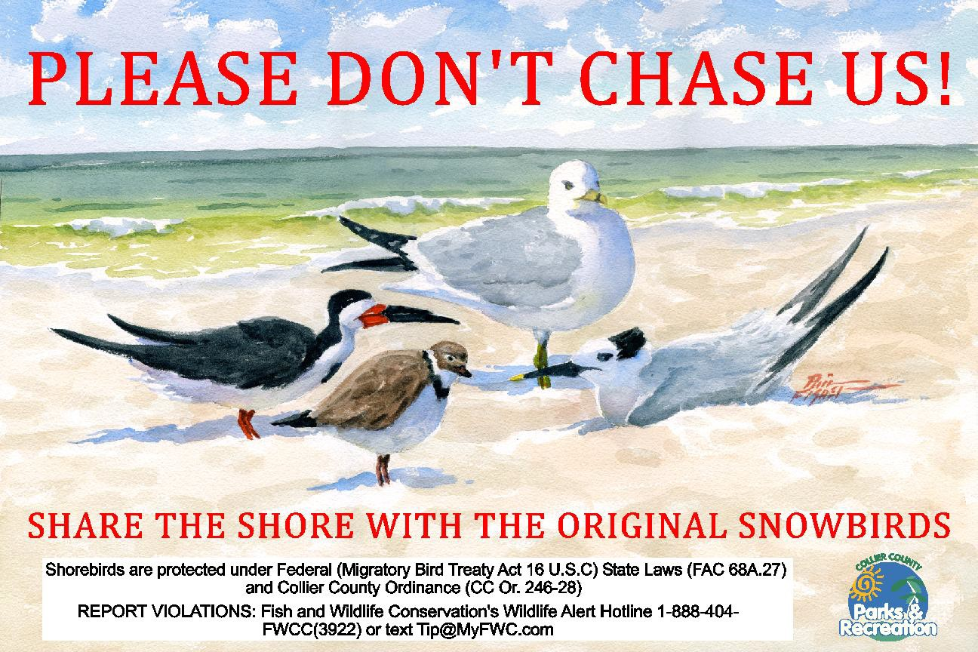
Local artist Phil Fisher donated the original artwork for this sign.

