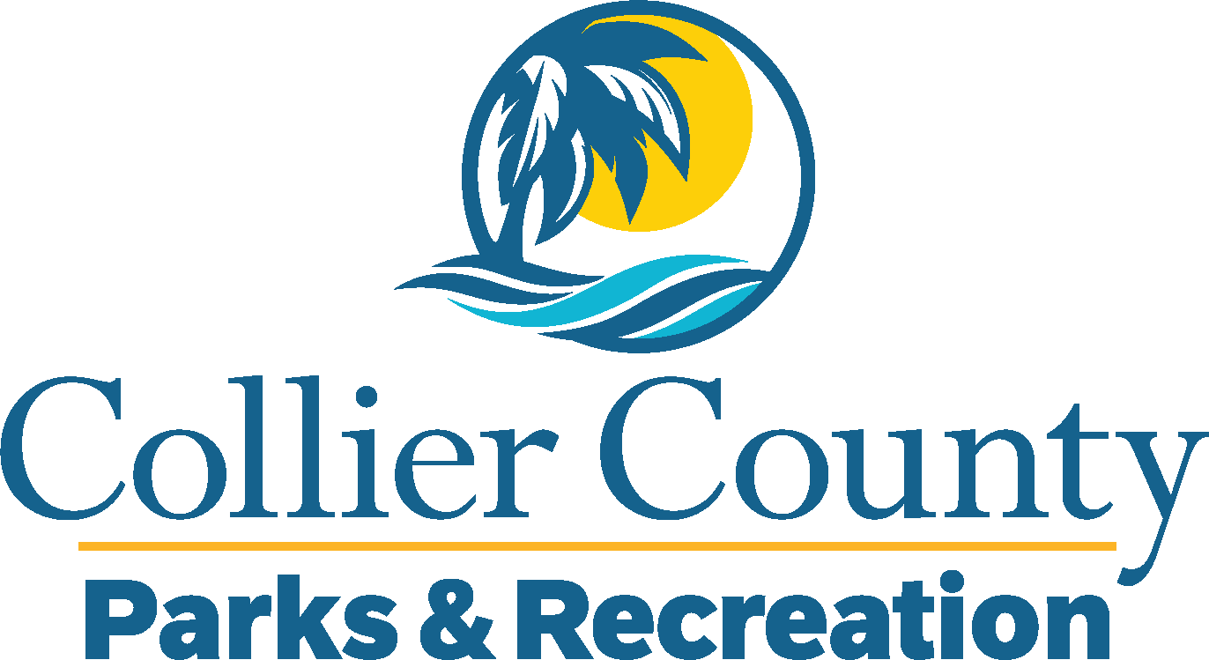
Parks & Recreation Advisory Board

meeting agenda
LOCATION: | NORTH COLLIER REGIONAL PARK
Date: | Wednesday, June 17, 2026
ADDRESS: | 15000 Livingston Road Naples, FL 34109
Time: | 2:00 PM
- Call to order
  - Welcome by the Director
  - Roll Call
  - Verification of Quorum
- Pledge of Allegiance and Invocation
- Approval of the Agenda
- Approval of Previous Meeting Minutes
- New Business
  - Vacant Chair – Carlos Cornelio
  - Fee Policy – James Hanrahan
- Additional Materials
  - Holiday Closure Schedule
- Board / Public comments
  - Adopt – A – Park – Advisory Board
- Manager Updates
- Director’s Report
- Adjournment

