Parks & Recreation Advisory Board

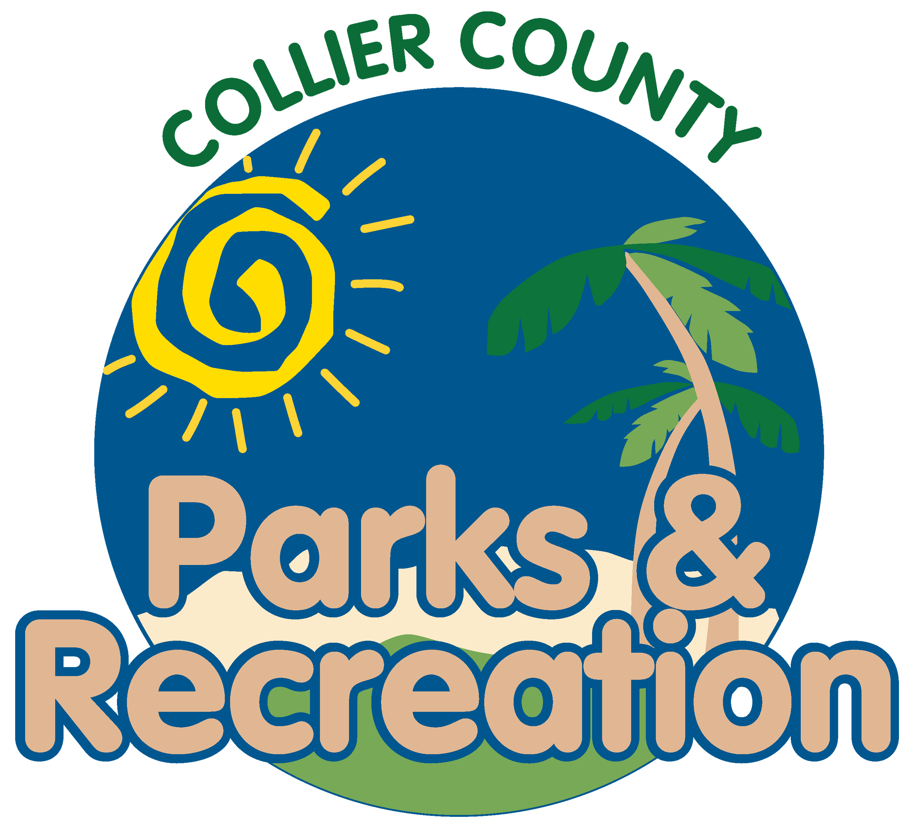
meeting agenda
LOCATION: | North collier regional park - administration
Date: | Wednesday, July 17, 2024
ADDRESS: | 15000 Livingston Road Naples, FL 34109
Time: | 2:00 PM
- Call to order
  - Welcome by Director
  - Roll Call
  - Verification of Quorum
- Pledge of Allegiance and Invocation
- Approval of the Agenda
- Approval of Previous Meeting Minutes
- new business
  - U.S. Open Pickleball Championship Presentation
  - Non-Motorized use on Lake Avalon
  - Summer Intern Presentation
- Public comments
- staff Reports
- Director’s Report
- Adjournment

