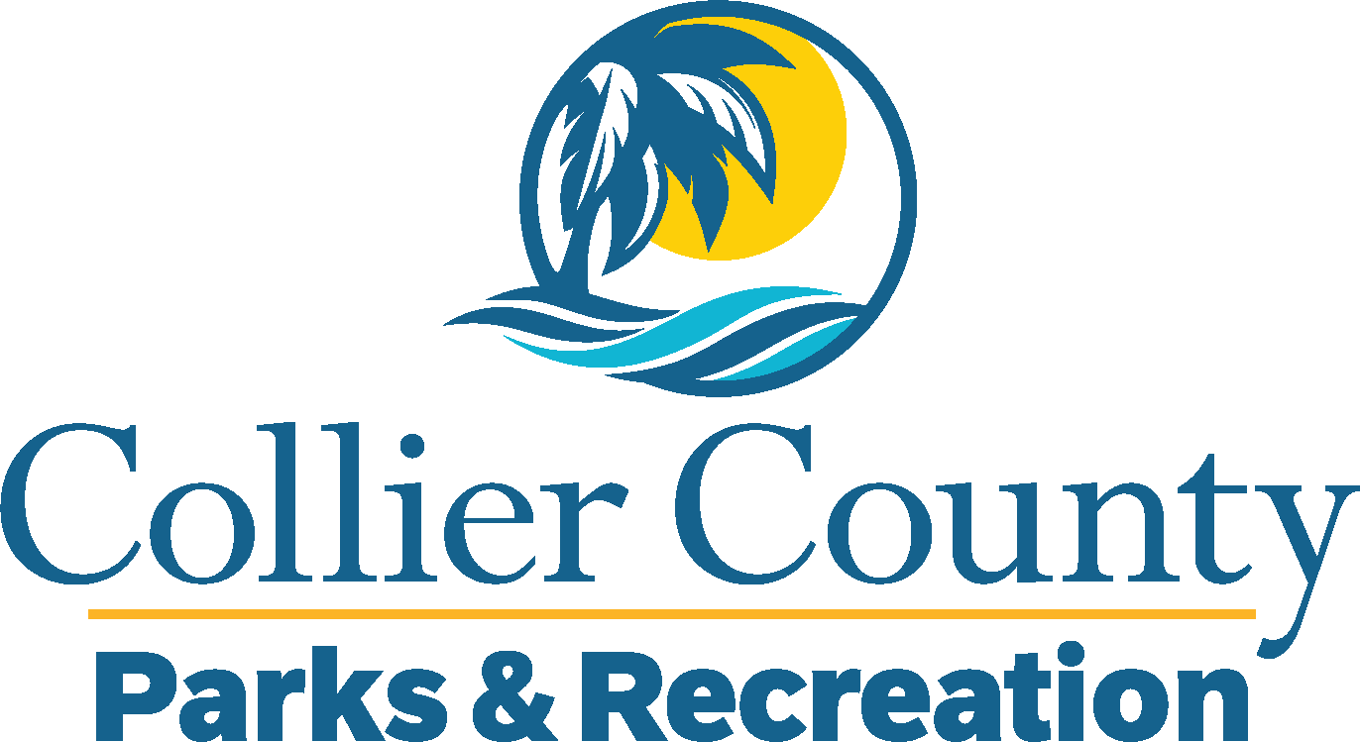
Parks & Recreation Advisory Board

meeting agenda
LOCATION: | NORTH COLLIER REGIONAL PARK
Date: | Wednesday, April 15, 2026
ADDRESS: | 15000 Livingston Road Naples, FL 34109
Time: | 2:00 PM
- Call to order
  - Welcome by the Director
  - Roll Call
  - Verification of Quorum
- Pledge of Allegiance and Invocation
- Approval of the Agenda
- Approval of Previous Meeting Minutes
- New Business
  - Ann & Ski Olesky Park – James Hanrahan
  - Chairman Selection – James Hanrahan
  - Budget Timeline – James Hanrahan
  - Sun N—Fun Update – James Hanrahan
  - Adopt – A – Park – Miguel Rojas
  - Name Tags – Miguel Rojas
  - Talent Development – James Hanrahan
- Old Business
  - Immokalee Sports Complex Update – James Hanrahan
- Additional Materials
  - Golden Gate Community Center Advisory Board Minutes
  - PARAB Manual
  - Directory
  - Organizational Chart
  - Calendar
- Board / Public comments
- Manager Updates
- Director’s Report
- Adjournment

