




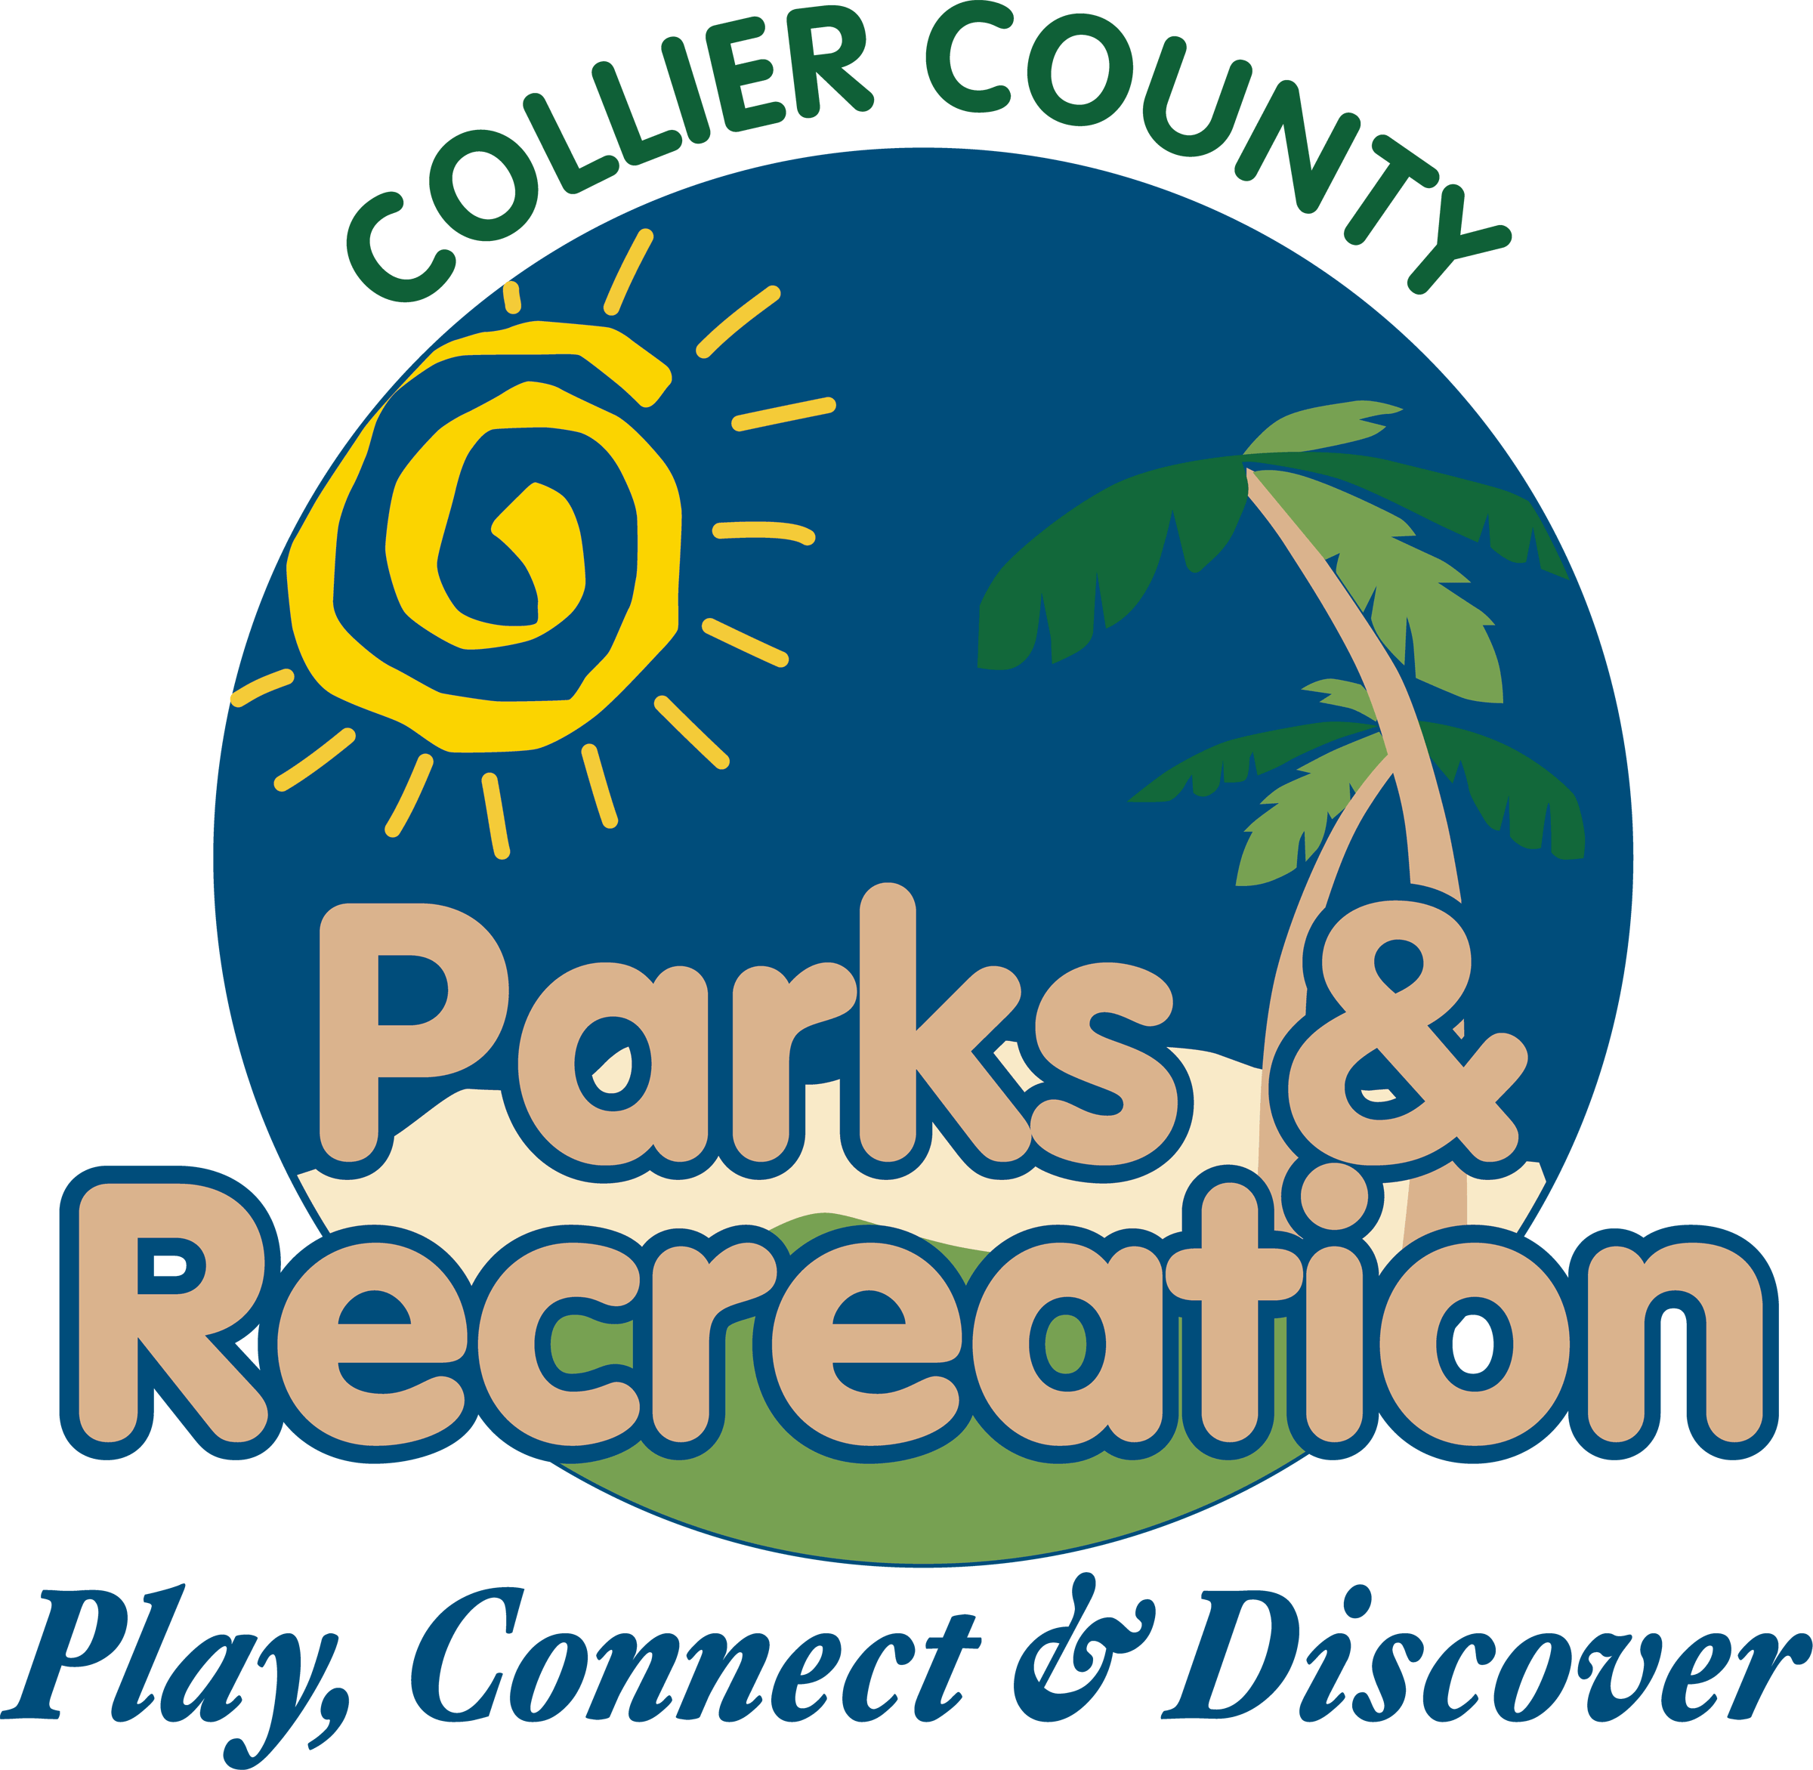
- Call to Order
- Pledge of Allegiance and Invocation
- Approval of Agenda
- Approval of January 20,2016 Minutes
- Staff Highlights
  - Parks After the Storm (Jan. 16) – Rick Garby
  - Caxambas Conversion –
Amanda Townsend
- New Business
- Alcohol Permission –
Harvest Festival
- Parks Capital Project
Plan
- Adopt a Park reports
- Director Highlights—
Barry Williams
- Informational Items
- Public Comments/Board Comments
- Adjournment

Parks and Recreation
Advisory Board Meeting
February 17, 2016 2:00PM
Immokalee Community Park

